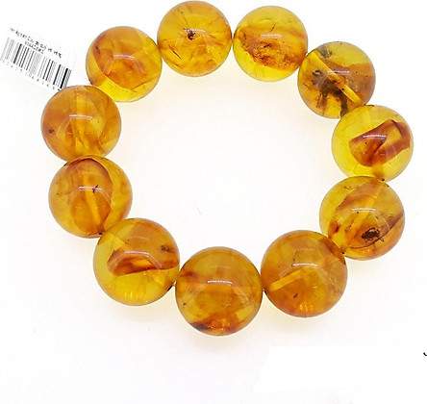**Rock amber ring uses for users:**

**Amber can be used as a remedy for liver and bile ailments.**

**Help the user's spirit become comfortable, light, refreshing. At the same time, amber stone helps heal and restore the nervous system, balancing the two hemispheres of the brain.**

**Bring transportation, luck and peace to the user.**

**Material: natural Baltic amber**

**Color: honey yellow**

**Weight: 46.78 grams.**

**Size: 20mm beads (11 beads)**

**Match destiny: Metal destiny, Tho destiny.**

**Uses: has the effect of enhancing human resistance.**